SKEMA RANGKAIAN ROBOT LINE FOLLOWER MIKRO
Sensor photodiode
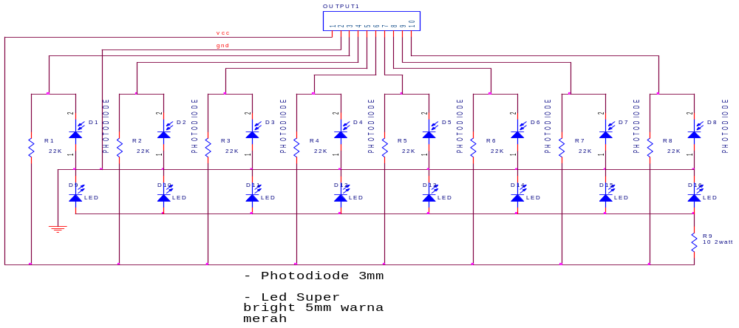
Komparator LM324
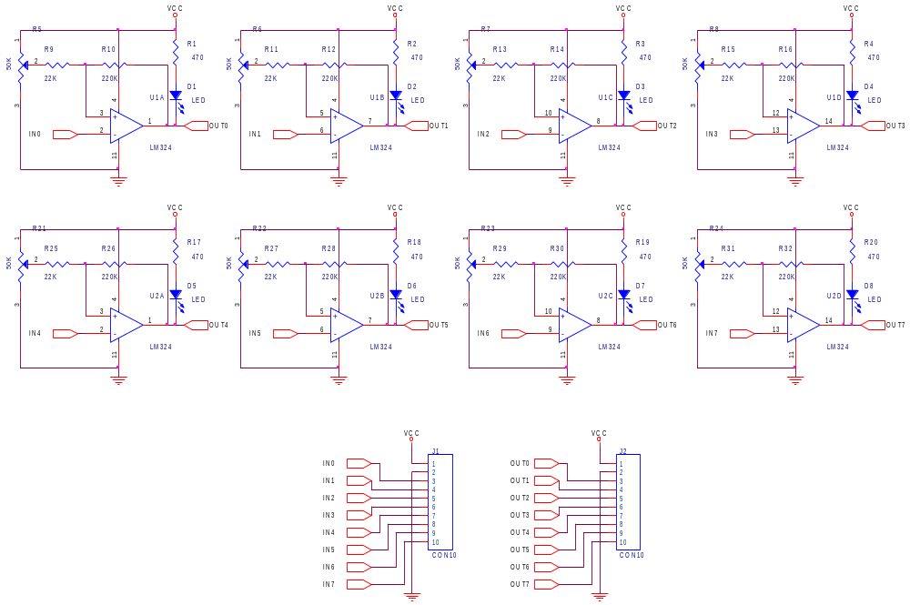
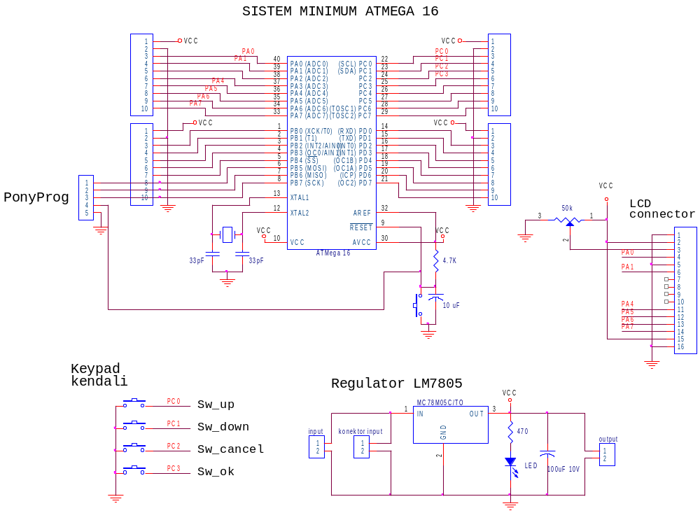

Driver motor IC L293D
